Ok, so I read in EMG data and kinematics and am trying to figure out the alignment between all the data streams.

I just read in the EMG from Plexon and the kinematics straight from Vicon. I then plot EMG and Vicon in the same window, after downsampling the EMG by 5 (1000Hz Emg, 200Hz Vicon). Here’s the plot, EMG on the top, Vicon on the bottom. This is zooming into a region where the animal behaved weirdly so it’s a good signature. The first rectangle goes from the last good Vicon step before the break to the last good EMG before the break. The next ones similarly align peaks before gaps in the behavior.

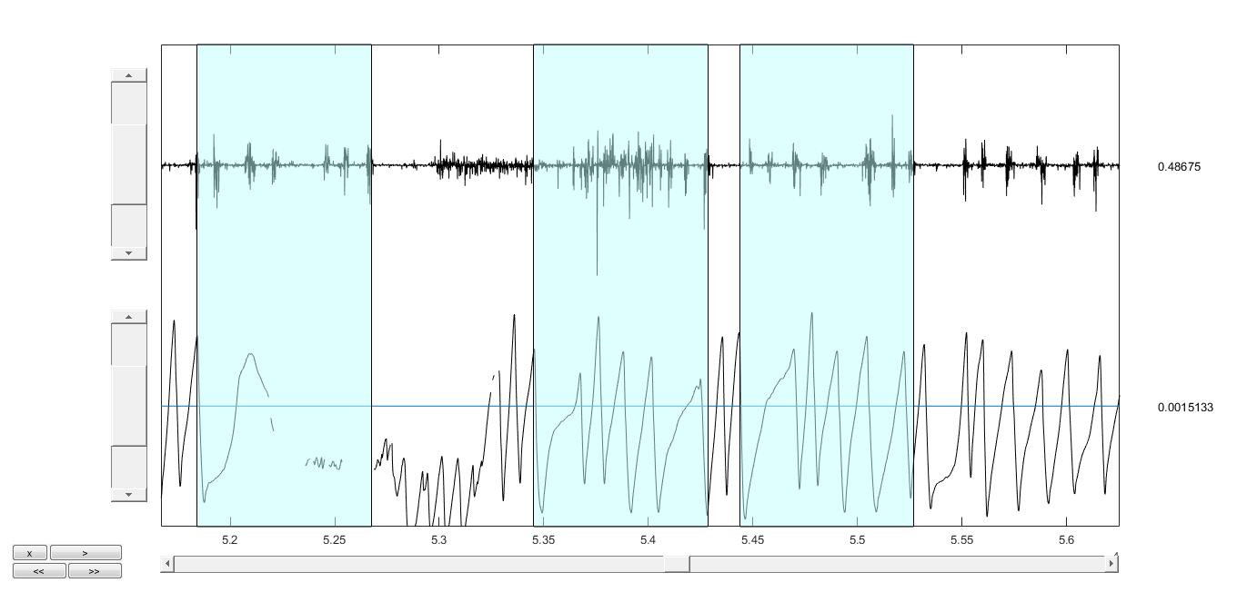

835.2182 835.2182 830.8681

These are the widths of the windows in terms of numbers of samples. So there are approximately 835 samples shift between the two streams. Note that this is actually around 835*5 samples in the Plexon data stream, or 4176 samples.

Now I look at the channel in PLexon that has the Vicon synch channel. I find that the sample at which the signal goes high is 4076. So this matches fairly well. The plot below is showing the EMG in the top and the Vicon in the bottom, after this alignment.

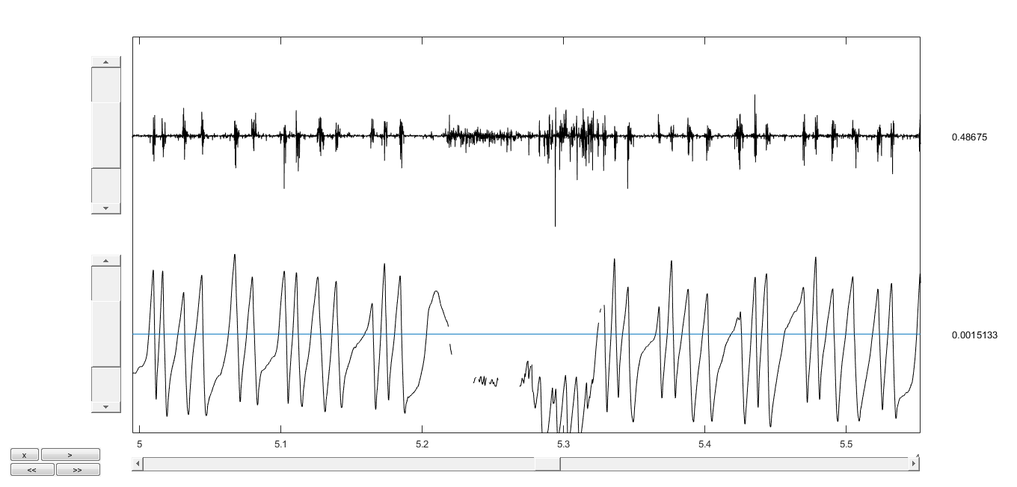

It seems pretty good.

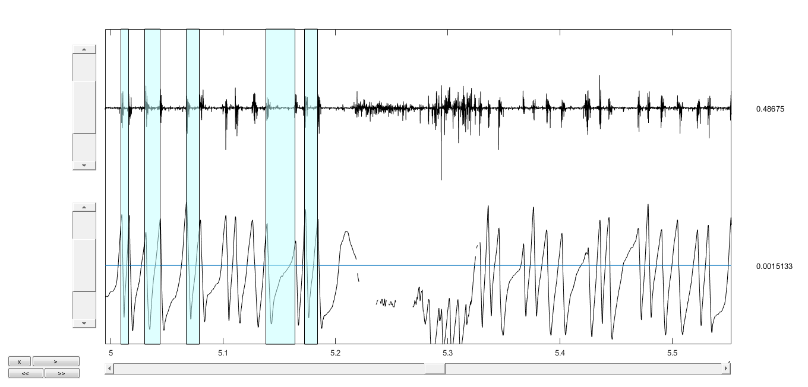

Ok, so this alignment is ok here. Now let’s go through the next steps of the analysis.

OK, so I now I go through the next steps in the analysis that are in the Epidural wrapper, which bins the Epidural (EMG in this case) and kinematics data streams. I think do the same plot (I think), and get the plot below.

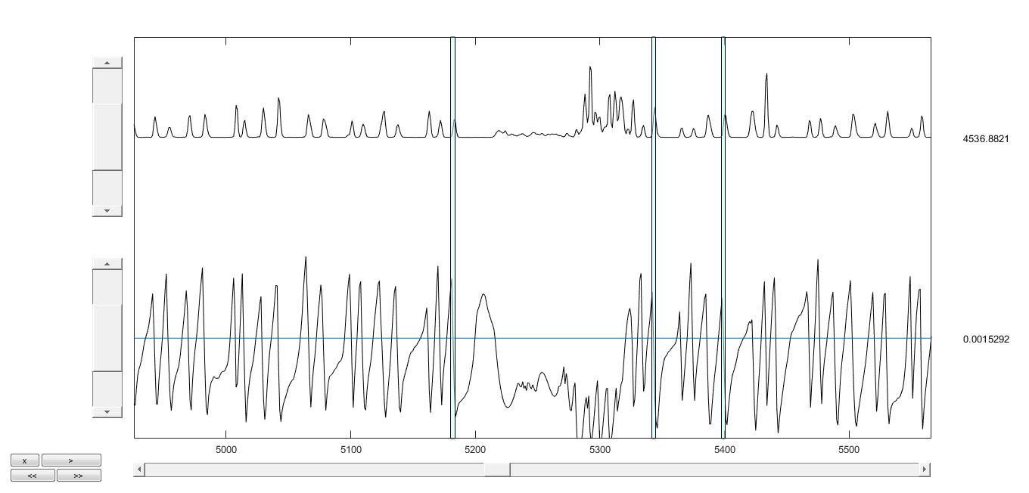

The size of the rectangles is

3.6433 3.0361 3.0361

In samples. This is number of bins. So there’s approximately 150ms between EMG and kinematics.

OK, so now I went through the next steps of the process, using EMG power to predict kinematics after alignment.

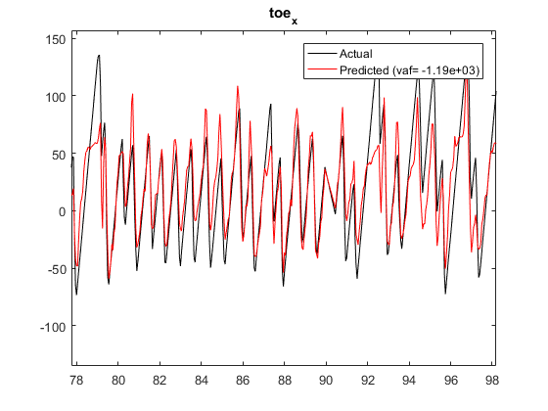

The VAF is likely because of very bad prediction at a particular part of the file, as shown in the figure below.

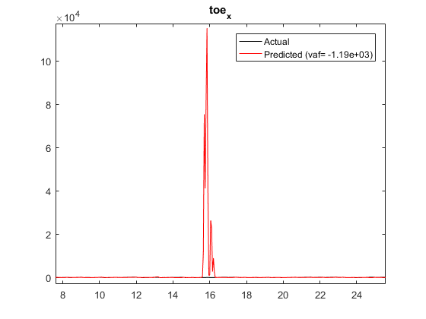

Ok so that shows that I can predict kinematics from EMGs. Now I want to try doing the same things from neurons. I have two structures, plexondata and an_data.

I need to:

* Align the data times – it looks like that’s just eliminating the first times from the matrices – ideally, it’s more precise by subtracting the temporal offset from the spike times, then doing that before the binning.
* Once I have that, it’s just a matter of assembling the data structure that is sent to the decoder. I would keep the output variable as before, but instead of the Epi power, I’ll put in the spike firing rates.

This is using that single modulated neuron!

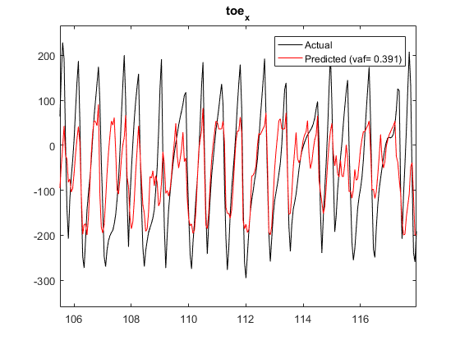

This is predicting TA EMG

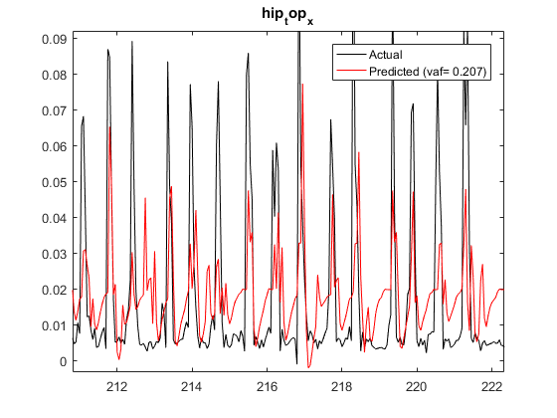

Using all neurons to predict kinematics:

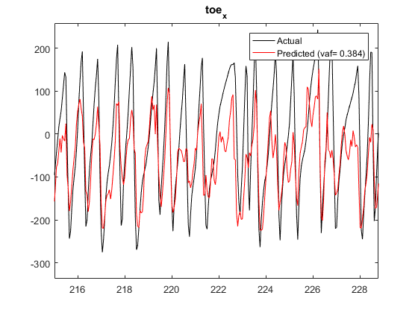

Predicting one of the EMGs – channel 1:

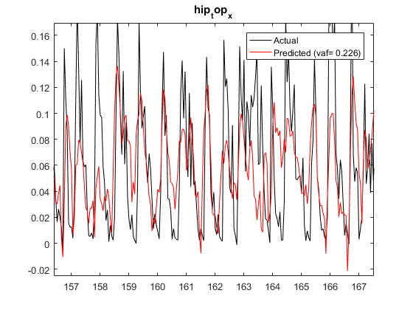

Predicting one of the other EMG Channels- again with a single neuron.

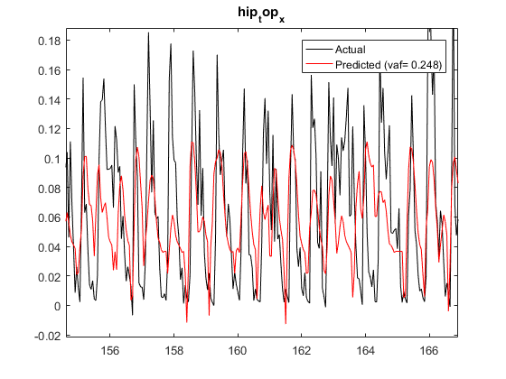

Predicting kinematics from EMGs:

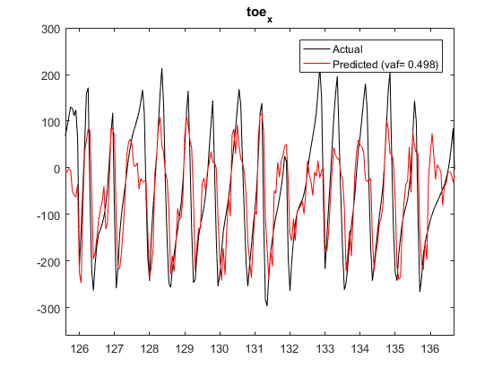

Predicting kinematics with LFPs

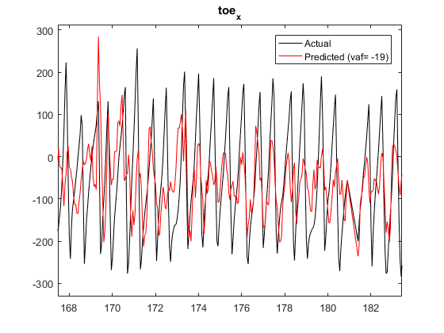

This is eliminating some of the bad parts of the file:

